**ОБРАЗЕЦ ЗАДАНИЙ ДЛЯ САМОСТОЯТЕЛЬНОЙ РАБОТЫ**

*Example 1: Be ready to answer the given questions (see the picture) to play the board game in class*

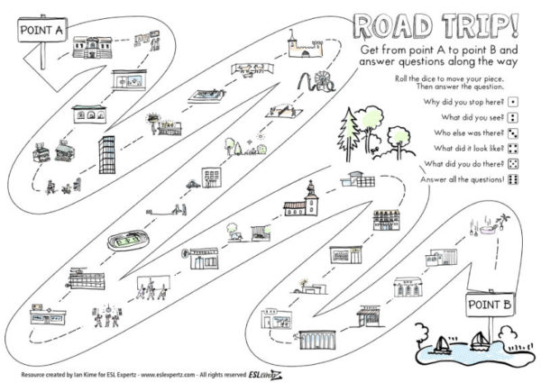

*Example 2: Make up a crossword using the example below*

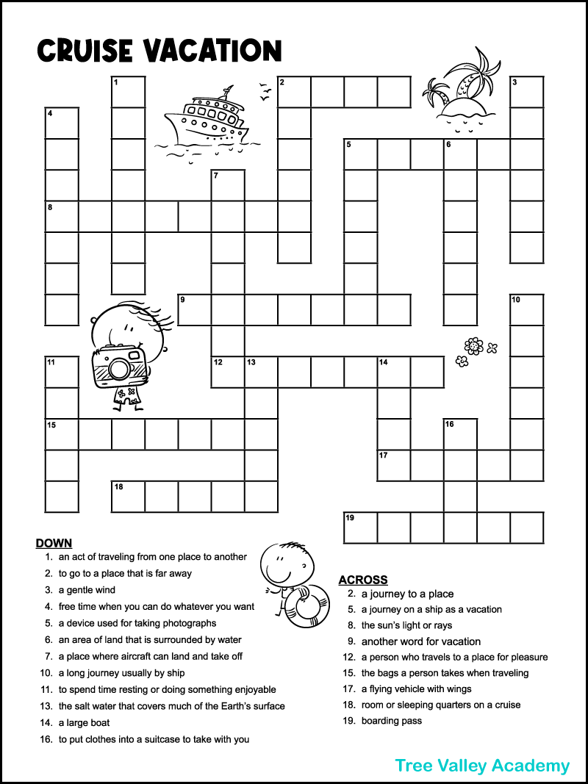

*Example 3: Complete this catering survey about the area you live in. Write a short entry for an online guide about the catering services available in your area. Include a general introduction and some specific recommendations. You could give marks for cost, atmosphere, service, food and drink and suggest the best dishes to try. Present it to the group.*

