ОБРАЗЕЦ ТЕКСТОВ ДЛЯ ОБСУЖДЕНИЯ
ПО ДИСЦИПЛИНЕ «ПРАКТИКУМ МЕЖКУЛЬТУРНОЙ КОММУНИКАЦИИ НА ВТОРОМ ИНОСТРАННОМ ЯЗЫКЕ» (факультатив)
Дневная и заочная формы обучения
Text 1.
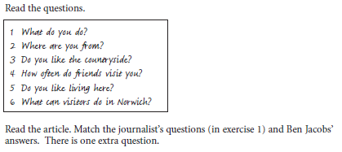
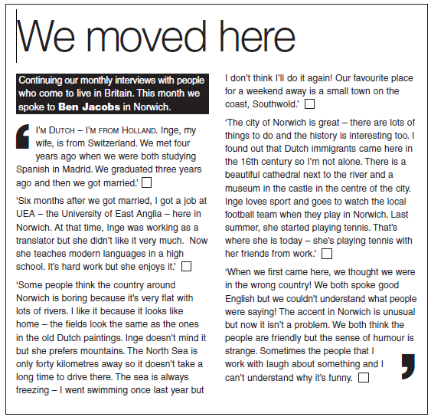
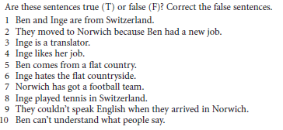
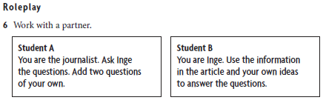

Text 2.
JAPAN AND U.S. CANDY VENTURE
A well-known U.S. candy company was interested in selling its product overseas. The company found a possible partner based in Tokyo, Japan. The Tokyo company seemed to be perfect for the deal. After many phone calls between the two parties, a decision was made to meet in Tokyo. The U.S. company chose one of their businessmen, Nick Taner, to represent it in Tokyo. He was the company's most persuasive negotiator.
Before Taner left the United States, he and the company lawyer worked together to write a detailed contract for the deal. The contract was fifty pages long. The deal would be advantageous for both companies. It promised big profits.
Taner left for Japan with the contract. He was pleased with his careful preparation. He thought his future partners would be satisfied with his work and would be ready to bargain about the details in the contract. He had studied their company interests and was sure they would want to change a few conditions in the contract. He planned to agree to those changes as concessions. He was certain the meetings would result in good negotiations and a quick final agreement.
On the day of the meeting in Tokyo, Taner entered the boardroom with copies of the contract for the Japanese businessmen at the meeting. He handed them each a copy and began discussing the details. The representatives of the Tokyo company did not open their contracts. They didn't discuss the contract at all, but instead spoke about general business issues. They spoke about the proposed cooperation between the two companies but they didn't make any promises.
Taner then went back to the United States. He felt extremely surprised and disappointed. The Japanese businessmen had never asked him one question about the contract. No agreements or commitments had been made. He wasn't even sure if there would be another round of negotiations.
L. Monahon, S. Lynn. Business across cultures

Reviewing the Case
Answer the following questions and share your answers with a partner.
1. How did the two companies first communicate with each other?
2. How did the American representative prepare for the first meeting?
3. How did the Japanese businessmen respond to the contract?

Making Inferences
Answer the following questions and share your answers with a partner.
1. Why do you think Nick Taner brought a contract to the first meeting?
2. Why do you think the Japanese representatives didn't look at the contract during the first meeting? What did they expect from that meeting?
3. Why do you think the two parties failed to reach an agreement?

