УЧРЕЖДЕНИЕ ОБРАЗОВАНИЯ
«БЕЛОРУССКИЙ ГОСУДАРСТВЕННЫЙ ЭКОНОМИЧЕСКИЙ УНИВЕРСИТЕТ»
М.А. Кашляк
Learn to Read English Texts
Учебно-методическое пособие по иностранному языку (английскому) для студентов I курса специальностей 1-25 01 13 «Экономика и управление туристской индустрией», 1-25 01 10 «Коммерческая деятельность», 1-25 01 14 «Товароведение и торговое предпринимательство»,
1-25 01 16 «Экономика и управление на рынке недвижимости» дневной и заочной формы обучения факультета коммерции и туристской индустрии

Минск: БГЭУ, 2018
Рецензент: К.А. Белова, доцент кафедры профессионально ориентированной английской речи БГЭУ, кандидат филологических наук

Рекомендовано кафедрой профессионально ориентированной английской речи УО БГЭУ.

Кашляк, М.А.
Learn to Read English Texts. Учебно-методическое пособие по английскому языку для студентов I курса специальностей 1-25 01 13 «Экономика и управление туристской индустрией», 1-25 01 10 «Коммерческая деятельность», 1-25 01 14 «Товароведение и торговое предпринимательство», 1-25 01 16 «Экономика и управление на рынке недвижимости» дневной и заочной формы обучения факультета коммерции и туристской индустрии / М.А. Кашляк – Минск, БГЭУ, 2018. – 37c.

Предлагаемое вниманию читателей учебно-методическое пособие направлено на развитие навыков чтения на английском языке по тематике, предусмотренной учебной программой по учебной дисциплине «Иностранный язык (английский)».
Contents

- CHARACTER AND APPEARANCE 4

- FAMILY RELATIONS 15

- MEALS AND COOKING 25

- References 37

Unit 1

CHARACTER AND APPEARANCE
Task 1. Look through the following idioms and quotations. Try to guess their meaning and find Russian equivalents. Do you agree or disagree with them.
- Appearances are deceptive.
- Clothes count for first impressions.
- Not a hair out of place.

Task 2. Read the text paying attention to focus vocabulary.
Appearances are deceptive. It is a common truth; practically everyone has met at least someone whose character and appearance differ radically.
When one sees a tall, broad-shouldered youth, one expects him to be strong-willed and brave. One thinks: 'A model to follow!' How often a good-looking individual turns out to be petty, weak-willed or even cowardly. Then one thinks: 'A mediocrity!'
At the same time everyone knows that a lot of great people were of a poor build: short and fragile. It did not stop them from displaying intelligence and courage. Ingenuity does not depend on one's complexion or constitution.
Plump or fat people create an impression of generous and kind personalities. Strangely enough, not rarely they may be thrifty or even greedy. One usually thinks: 'A scrooge!'
On the other hand, thin or slim nervous ladies often tend to be lavish. They like to buy and never think twice when they pay. One thinks: 'I would call her open-handed and Mother would call her a spendthrift'. Yes, mothers are always stricter in judgements.
Has it ever happened to you that you come to an important office and see an important boss? You immediately evaluate his looks: 'Round-faced, small narrow eyes, dimples on the cheeks and an upturned nose. What a kind-hearted person! A simpleton!' You tell the boss of your troubles and expect immediate help. But the boss appears to be rude, harsh and willful. You never get your help and think: 'A stone heart and an iron fist'.
When someone sees a delicately built pretty blonde with curly hair, blue eyes, a straight nose and a high forehead, one is inclined to think that the beauty is intelligent and nice. It may be disappointing to think later 'What a stupid, capricious, impolite bore!'
On the contrary, when one sees a skinny brunette with ugly irregular features — a hooked nose, pointed chin, close-set eyes and thin lips, strange thoughts come to one's head; because it is the image of evil people — cruel and cunning. It may be a relief some time later to find her a clever, gentle and good-mannered lady and think: 'What charm! A heart of gold!'
Another general misconception lies in the fact that children are always expected to resemble their parents. And parents like it when children take after them. Relatives like to compare moles, the shape of noses, etc. The greatest compliment is: "They are as like as two peas'. The greatest disappointment is to find nothing in common. We want to deny people their exclusiveness, we don't want to admit that nature has selected other options from an enormous genetic fund developed over generations. Why do we like our copies? Who knows!
Nature likes to play tricks on us. But don't you think it is a present on the part of nature? Life becomes not a boring routine, but a brilliant kaleidoscope of characters and appearances which often clash.
Task 3. Look at the pictures below and choose the right word from the lists to describe the shape of one's face, eyes, nose, chin, lips, forehead.
Face:
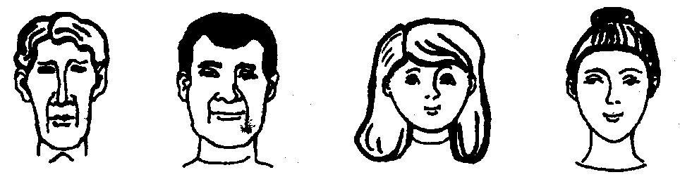
a) oval b) round c) long d) square
Eyes:
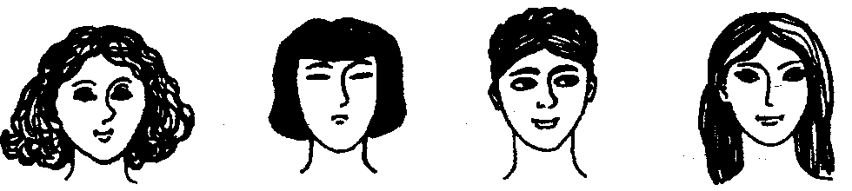
a) almond b) slanting c) round d) narrow
Nose:
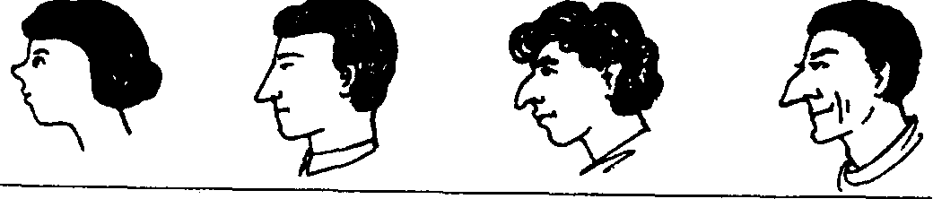
a) aquiline b) hooked c) straight d) upturned
Chin:
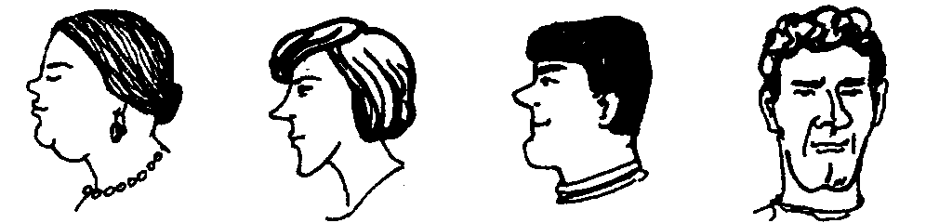
a) protruding b) split c) double d) pointed
Lips:
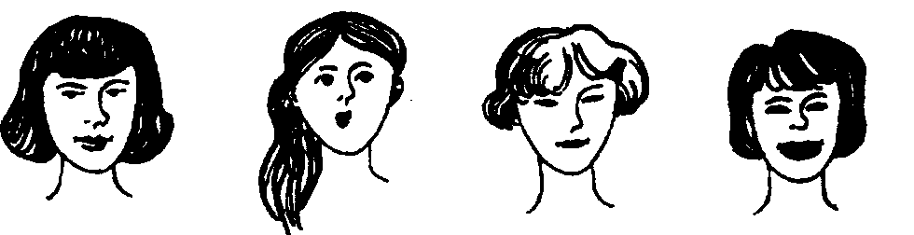
a) thin b) plump c) thick d) heart-shaped
Forehead:
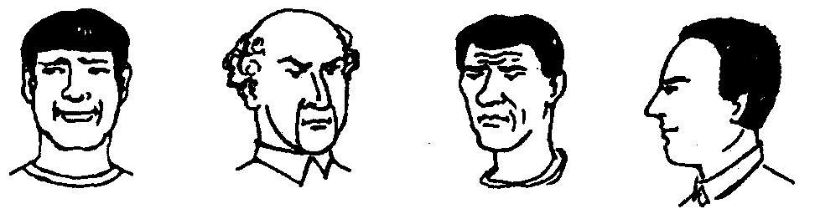
a) wrinkled b) narrow c) balding d) high

Task 4. Complete the dialogues with the right question.
What does she look like?
What is she like?
How is she?

- Richard is short and heavily built. He has dark hair, going a little bald, and big black eyes.
- The girl was delicately-built, very slender, with full lips and deep-set eyes. They looked sad and made you feel sorry for her.
- Jenny is very kind, intelligent and tolerant to whatever she sees or hears. She’s like a good old friend to me.
- She is a lovely little girl of about five, plump, with an upturned nose and dimpled rosy cheeks. Her hazel eyes and silky long hair add to her attraction.
- Melancholy and perplexed, the woman was sitting at the table. Her faded eyes were grave and she looked upset.
- Cruel but very clever and shrewd, he was quite an extraordinary person.
- Mark is dark-haired and romantically handsome, with his merry laugh and charm.
- Rachel is a bit old-fashioned and she is sweet in a way. Her eyes are close-set and a little slanting but they don't spoil her pale oval face.
- Jack looks very much like her Dad. She’s got the same beautiful eyes and the same colour hair.
- Oh, Gerald is alright now. He is already at home, recovering.
- He isn't even that handsome: his proportions are wrong; he is too tall for his shoulders; his hair is too short; his arms are too long.
- The immigration officer is wearing a dark-green uniform, like a soldier's, and there are two actual soldiers leaning against the wall beside him, in crisp blue shirts with short sleeves.
- There's a tiny woman, not five feet tall. She's wearing a fur coat and a black wool jockey cap tilted at an angle. She must be at least seventy but it's hard to tell.
- He is like iron. All of us knew that he was not easily put off and that nothing could make him change his mind.
- She was unable to control her jealousy, and her friends sometimes called her an Othello in spite of her being a woman.
- Alan is extremely bright, but he is not snobbish at all. He’s somewhat romantic, maybe, a bit dreamy.
- Betty is fine, thanks.
- Monica is an attractive girl – pretty, of medium height, with fair curly hair and freckles all over the face.
- An awfully handsome man: tall, with dark wavy hair, straight nose and a broad forehead.
- Phil looked pretty exhausted. He had had no sleep the last night as he had a great deal to do in the hospital and could never find an hour or two to have a nap.
- Amanda is not very well, I’m afraid. She parted with Max and in addition she’s lost her job.

Task 5. Read the text and do the exercises.
Young Archimedes

(Extract from the story by A. Huxley "Young Archimedes". Abridged.)

It was the view which finally made us take the place. Our nearest neighbours lived very near. We had two sets of them, as a matter of fact, almost in the same house with us. One was the peasant family. Our other neighbours were the owners of the villa.
They were a curious people, our proprietors. An old husband, grey, listless, tottering, seventy at least; and a signora of about forty, short, very plump, with tiny fat hands and feet and a pair of very large, very dark eyes, which she used with all the skill of a born comedian.
But we had found other reasons, after a few days' residence, for liking the house. Of these the most cogent was that, in the peasant's youngest child, we had discovered the perfect play-fellow for our own small boy. Between little Guido — for that was his name — and the youngest of his brothers and sisters there was a gap of seven years. He was between six and seven years old and as precocious, self-assured, and responsible as the children of the poor generally are.
Though fully two and a half years older than little Robin — and at that age thirty months are crammed with half a lifetime's experience — Guido took no undue advantage of his superior intelligence and strength. I have never seen a child more patient, tolerant, and untyrannical. He never laughed at Robin; he did not tease or bully, but helped his small companion when he was in difficulties and explained when he could not understand. In return, Robin adored him, regarded him as the model and perfect Big Boy, and slavishly imitated him in every way he could.
Guido was a thoughtful child, given to brooding. One would find him sitting in a corner by himself, chin in hand, elbow on knee, plunged in the profoundest meditation. And sometimes, even in the midst of the play, he would suddenly break off, to stand, his hands behind his back, frowning and staring at the ground. And his eyes, if one looked into them, were beautiful in their grave and pensive calm.
They were large eyes, set far apart and, what was strange in a dark-haired Italian child, of a luminous pale blue-grey colour. They were not always grave and calm, as in these pensive moments. When he was playing, when he talked or laughed, they lit up. Above those eyes was a beautiful forehead, high and steep and domed in a curve that was like the subtle curve of a rose petal. The nose was straight, the chin small and rather pointed, the mouth drooped a little sadly at the corners.
My gramophone and two or three boxes of records arrived from England. Guido was immensely interested. The first record he heard, I remember, was that of the slow movement of Bach's Concerto in D Minor for two violins. That was the disc I put on the turn-table.
Guido came to a halt in front of the gramophone and stood there, motionless, listening. His pale blue-grey eyes opened themselves wide; making a little nervous gesture that I had often noticed in him before, he plucked at his lower lip with his thumb and forefingers.
After lunch he reappeared. 'May I listen to the music now?' he asked. And for an hour he sat there in front of the instrument, his head cocked slightly on one side, listening while I put one disc after another. Thenceforward he came every afternoon.
What stirred him almost more than anything was the Coriolan overture. One day he made me play it three or four times in succession; then he put it away.
'I don't think I want to hear that any more,' he said.
'Why not?'
'It's too... too...' he hesitated, 'too big,' he said at last. 'I don't really understand it. Play me the one that goes like this.' He hummed the phrase from the D Minor Concerto.
'Do you like that one better?' I asked.
He shook his head. 'No, it's not that exactly. But it's easier.'
'Easier?' It seemed to me rather a queer word to apply to Bach.
In due course, the piano arrived. After giving him the minimum of preliminary instruction, I let Guido loose on it. He made excellent progress. Every afternoon, while Robin was asleep, he came for his concert and his lesson. But what to me was more interesting was that he had begun to make up little pieces on his own account. He had a passion for canons. When I explained to him the principles of the form he was enchanted.
'It is beautiful,' he said, with admiration. 'Beautiful, beautiful. And so easy!'
Again the word surprised me.
But in the invention of other kinds of music he did not show himself so fertile as I had hoped.
'He's hardly a Mozart,' we agreed, as we played his little pieces over. I felt, it must be confessed, almost aggrieved.
He was not a Mozart. No. But he was somebody, as I was to find out, quite extraordinary. It was one morning in the early summer that I made the discovery. I was sitting in the warm shade of our balcony, working. Absorbed in my work, it was only, I suppose, after the silence had prolonged itself a considerable time that I became aware that the children were making remarkably little noise. Knowing by experience that when children are quiet it generally means that they are absorbed in some delicious mischief,1 got up from my chair and looked over the balustrade to see what they were doing. I expected to catch them dabbling in water, making a bonfire, covering themselves with tar. But what I actually saw was Guido, with a burnt stick in his hand, demonstrating on the smooth paving-stones of the path, that the square on the hypotenuse of a right-angled triangle is equal to the sum of the squares on the other two sides. Robin listened, with an expression on his bright, freckled face of perfect incomprehension.
Guido implored: 'But do just look at this. It's so beautiful. It's so easy.'
So easy... The theorem of Pythagoras seemed to explain for me Guide's musical predilections. It was not an infant Mozart we had been cherishing; it was a little Archimedes with, like most of his kind, an incidental musical twist.
Leaning on the rail of the balcony, I watched the children below. I thought of the extraordinary thing I had just seen and of what it meant.
I thought of the vast differences between human beings. We classify men by the colour of their eyes and hair, the shape of their skulls. Would it not be more sensible to divide them up into intellectual species? There would be even wider gulfs between the extreme mental types than between a Bushman and a Scandinavian. This child, I thought, when he grows up, will be to me, intellectually, what a man is to a dog.

Exercise 1
Match the words on the left with the meaning on the right.
Adjectives:
1. curious A. thinking deeply about something
2. listless B. having no energy or enthusiasm
3. tolerant C. having or showing good reasoning power
4. pensive D. allowing other people to say and do what they think is right even if one doesn't agree with it
5. intellectual E. being able to stay calm and not get annoyed
6. tyrannical F. acting cruelly and unjustly towards the people who one controls
7. patient G. unusual and interesting

Verbs:
1. totter A. make fun of somebody, deliberately embarrass somebody
2. bully B. walk in an unsteady way
3. tease C. delight, bewitch, charm somebody
4. stir D. care lovingly and tenderly
5. enchant E. think about something a lot seriously and often unhappily
6. cherish F. excite somebody, make one react with a strong emotion
7. brood G. use one's strength or power to hurt or frighten somebody

Exercise 2

I. Draw lines between the pairs matching the words on the left with their opposites on the right.
self-assured calm
fat undelightful
dark-haired inferior
nervous thin, slender
delicious fair-haired
listless miserable
superior energetic
steep rough
smooth sloping
II. Draw lines between the pairs matching the words on the left with the words or phrases of similar meaning on the right.
plump prematurely developed
tiny reasonable
precocious rather fat
sensible odd
queer exceptional
extraordinary convincing
cogent still
motionless serious
grave extremely small

Exercise 3

Choose a suitable word or phrase from the passage you have read to complete the sentences.
1. The owners of the villa were a ... people. There was a... of almost thirty years between husband and wife.
2. The signora had very large, black eyes and she used them with ... .
3. Robin adored Guido, he ... him as the ... and copied him in ... he could.
4. Being a ... child, Guido was given to ... and liked to sit... , chin .... elbow ....... in the profoundest meditation.
5. Sometimes Guido suddenly interrupted the game and stood ... at the ground.
6. If you looked into Guide's eyes you would find out that they were beautiful in their ... and ... calm. They were set... .
7. When Guido was listening to the music, he ... at his lower lip with his ... and ... .
8. Soon Guido started ... little pieces on ... . He had ... for canons.
9. Guido was really ... by canons and the principles of the form.
10. When Robin's parents played Guide's little pieces over they felt almost....
11. There was an expression of ... on Robin's bright and ... face when Guido was... the theorem of Pythagoras to him.
12. The author expected the boys to be ... in some ... , to ... them ... in water or ... a bonfire.
13. Guido appeared to be not an... Mozart, Robin's parent had been ... but... Archimedes with an ... musical twist.
14. There was a wide ... between Guido and Robin as between the two different... types.

Exercise 4

Fill in the blanks in the following sentences. Use only one expression in each space. Change the form of a word or a phrase if necessary.

to laugh at somebody to be an Archimedes
to make progress to shake one's head
to make up on one's own account
to make noise to put something away
in return to come to a halt
to know by experience to be crammed
to take advantage of something to be in difficulties

1. My brother is in the habit of... those people he has a grudge against.
2. The silence was oppressive. He ... that something was wrong.
3. She was so scared that she couldn't say a word. When the policeman asked her something she just ... to say "No".
4. Dick adored my daughter. As soon as she started playing the piano he ... near it and could stand motionless for half an hour enjoying both my daughter and the music.
5. You never know what's on his mind. It's characteristic of him to ... all sorts of stories. No wonder his friends do not have much confidence in him.
6. Sometimes it may be so annoying to look after kids. They like to ... when playing.
7. As Brian was left to himself and had to go through lots of difficulties his life appeared ... with all sorts of experience.
8. Little George is a special child; he is immensely interested in maths and physics. His parents and teachers are so proud of him that they say that he ....
9. Jane is always calm and patient and never loses her temper when explaining things to her pupils. That is why they just adore her... .
10. Practically all composers started writing music ... in early childhood.
11. One's career depends on how quickly he or she ... in acquiring new skills and knowledge.
12. In sports and games competitors always try to ... their opponents' mistakes and weaknesses.
13. After a child has played enough with his new toy, he ... and forgets about it for a while playing with his old favourite ones.
14. Noble and generous people always come to help their friends when the latter ....

Exercise 5

Give the English equivalents for the Russian words and expressions.
A.
Ходить пошатываясь, ковыляя; размышлять; задирать кого-либо; обожать; лелеять; быть очарованным; волновать кого-либо; подражать кому-либо; злоупотреблять чем-либо; прервать (занятие); преуспевать в чём-либо; увлекаться чем-либо; испытывать затруднения; умолять; дразнить; плескаться в воде.
В.
Гладкий; странный; апатичный; пухлый; развитой не по годам; самоуверенный; ответственный; веснушчатый; крутой (лоб); изящный; мечтательный; серьёзный; острый (подбородок); необыкновенный.
С.
Разница в семь лет; на целых два с половиной года старше; интеллектуальное и физическое превосходство; склонный к размышлению; заложив руки за спину; уставившись в землю; подперев подбородок рукой; опершись локтем о колено; широко расставленные глаза; уголки рта слегка опущены; глаза широко раскрылись; пощипывая нижнюю губу большим и указательным пальцами; нервный жест; слегка склонив голову набок; напевать без слов; музыкальные способности.

Exercise 6

Change the following sentences using the phrases from the text instead of the ones in italics.
1. Nick was five years younger than his brother.
2. Though Andrew was athletic and much stronger than all his play-fellows he never used it for his own benefit trying to overawe them with it.
3. Daniel always thought that his brother was a good example for him.
4. Having stayed several days at a health resort, we quickly got bored.
5. In fact, we were on good terms with our companions.
6. Frank was absolutely absorbed in watching a cowboy film and nothing could make him stop doing it.
7. After explaining the most important things to him I let him play the guitar as much as he wanted.
8. He did not feel determined enough and could not start a new business.
9. You can't divide people up into good and bad ones because human nature is not that simple.
10. The girl's face showed that she couldn't understand anything though she listened to the speech with great attention.
11. I was aware of his making progress in music but listening to his pieces you couldn't say he was as good as Mozart.
12. When Alex was told that she was stingy it made him feel upset and angry because he had never dreamed of having a stingy wife.
13. Nothing could move him more than a nice, quiet folk song performed by a peasant woman.
14. Ann's daughter is often absorbed in thinking deeply about something and whatever you say to her goes in one ear and out the other.

Exercise 7

Translate into English.

1. Наши друзья были владельцами виллы. Мистеру Редгрейву было около семидесяти, его жене — примерно сорок.
2. Младший из семьи Редгрейвов стал прекрасным другом для нашего малыша.
3. Малыш Дэнни был развит не по годам, уверен в себе и обладал большим чувством ответственности.
4. Я никогда не видел ребёнка более терпеливого и снисходительного к другим.
5. Дэнни не был тираном и не пользовался своим умственным и физическим превосходством.
6. Наш малыш считал своего друга образцом для подражания и всячески стремился доходить на него. .
7. Дэнни часто погружался в глубокие раздумья.
8. Он любил стоять, заложив руки за спину, нахмурившись и уставясь в землю.
9. Широко расставленные глаза Дэнни излучали тихий ясный свет.
10. Общее выражение лица мальчика было очень жизнерадостное, но уголки рта были как-то грустно опущены.
11. Когда мальчик слушал музыку и интересные истории, он сидел широко раскрыв глаза и слегка наклонив голову набок.
12. Больше всего его волновали истории с трагическим концом.
13. В математике Дэнни делал потрясающие успехи.
14. Поглощённый своими объяснениями, Дэнни не замечал, что лица его приятелей выражали полное непонимание.

Task 5. Read the article and render it according to the plan (see App.1)
Looking Good: The Psychology and Biology of Beauty

In ancient Greece, Helen of Troy was the paragon of beauty, showing a physical brilliance that would put Cindy Crawford to shame. Indeed, she was the toast of Athens, celebrated not for her kindness or her intellect, but for her physical perfection. But why did the Greek men find Helen, and other beautiful women, so intoxicating?
In an attempt to answer this question, the philosophers of the day devoted a great deal of time to this enigma. Plato wrote of so-called "golden proportions," in which, amongst other things, the width of an ideal face would be two-thirds its length, while a nose would be no longer than the distance between the eyes.
Today, this symmetry has been scientifically proven to be naturally attractive to the human eye. It has been defined not with proportions, but rather with similarity between the left and right sides of the face. Thus, the Greeks were only partially correct.
Babies spend more time staring at pictures of symmetric individuals than they do at photos of asymmetric ones. Victor Johnston of New Mexico State University, for example, uses a program called FacePrints, which shows viewers facial images of variable attractiveness. The viewers then rate the pictures on a beauty scale from one to nine. The pictures with the best ratings are merged together, while the less attractive photos are weeded out. Each trial ends when a viewer gives the composite a 10. All the perfect 10s are super-symmetric.
Scientists say that the preference for symmetry is a highly evolved trait seen in many different animals. Female swallows, for example, prefer males with longer and more symmetric tails, while female zebras mate with males with symmetrically colored leg bands.
The rationale behind symmetry preference in both humans and animals is that symmetric individuals have a higher mate-value; scientists believe that this symmetry is equated with a strong immune system. Thus, beauty is indicative of more robust genes, improving the likelihood that an individual's offspring will survive. This evolutionary theory is supported by research showing that standards of attractiveness are similar across cultures. According to a University of Louisville study, when shown pictures of different individuals, Asians, Latinos, and whites from 13 different countries all had the same general preferences when rating others as attractive - that is those that are the most symmetric.
The halo effect. In society, attractive people tend to be more intelligent, better adjusted, and more popular. This is described as the halo effect - due to the perfection associated with angels. Research shows attractive people also have more occupational success and more dating experience than unattractive ones.
An alternative explanation for attractive people achieving more in life is that we automatically categorize others before having an opportunity to evaluate their personalities, based on cultural stereotypes which say attractive people must be intrinsically good, and ugly people must be inherently bad.
For better or worse, the bottom line is that research shows beauty matters; it pervades society and affects how we choose loved ones. Thus, striving to appear attractive may not be such a vain endeavor after all. This isn't to say plastic surgery is necessarily the answer. Instead, lead a healthy lifestyle that will in turn make you a happier person.
Unit 2

FAMILY RELATIONS
Task 1. Look through the following idioms and quotations. Try to guess their meaning and find Russian equivalents. Do you agree or disagree with them?
- 'Keep your eyes wide open before marriage, half shut after.'
Benjamin Franklin
- 'An ideal wife is any woman who has an ideal husband.'
Booth Tarkington
- A tree is known by its fruit.
Task 2. Read the text paying attention to focus vocabulary.
FAMILY LIFE
Marriage is a thing which only a rare person in his or her life avoids. True bachelors and spinsters make up only a small percent of the population; most single people are "alone but not lonely".
Millions of others get married because of the fun of family life. And it is fan, if one takes it with a sense of humour.
There's a lot of fun in falling in love with someone and chasing the prospective fiancee, which means dating and going out with the candidate. All the relatives (parents, grandparents and great-grandparents, brothers and sisters, cousins, aunts and uncles, nieces and nephews, stepmothers and stepfathers and all in-laws) meanwhile have the fan of criticizing your choice and giving advice. The trick here is not to listen to them but propose to your bride-to-be and somehow get her to accept your proposal. Then you may arrange the engagement and fix the day of the wedding.
What fun it is to get all those things, whose names start with the word "wedding" — dress, rings, cars, flowers, cakes, etc.! It's great fun to pay for them.
It's fun for the bride and the groom to escape from the guests and go on a honeymoon trip, especially if it is a wedding present from the parents. The guests remain with the fun of gossiping whether you married for love or for money.
It's fan to return back home with the idea that the person you are married to is somewhat different from the one you knew. But there is no time to think about it because you are newly-weds and you expect a baby.
There is no better fan for a husband than taking his wife to a maternity home alone and bringing her back with the twins or triplets.
And this is where the greatest fan starts: washing the new-born's nappies and passing away sleepless nights, earning money to keep the family, taking children to kindergarten and later to school. By all means it's fan to attend parents' meetings and to learn that your children take after you and don't do well at school.
The bigger your children grow, the more they resemble you outwardly and the less they display likeness with you inwardly. And you start grumbling at them and discussing with your old friends the problem of the "generation gap". What fan!
And when at last you and your grey-haired spouse start thinking that your family life has calmed down, you haven't divorced but preserved your union, the climax of your fan bursts out!
One of your dearest offsprings brings a long-legged blonde to your house and says that he wants to marry. And you think: 'Why do people ever get married?'

Task 3. Look at the picture. Choose one of the names in the family tree below and say how the person is related to other people. Note that the pictures of marriage partners are connected with wedding rings.
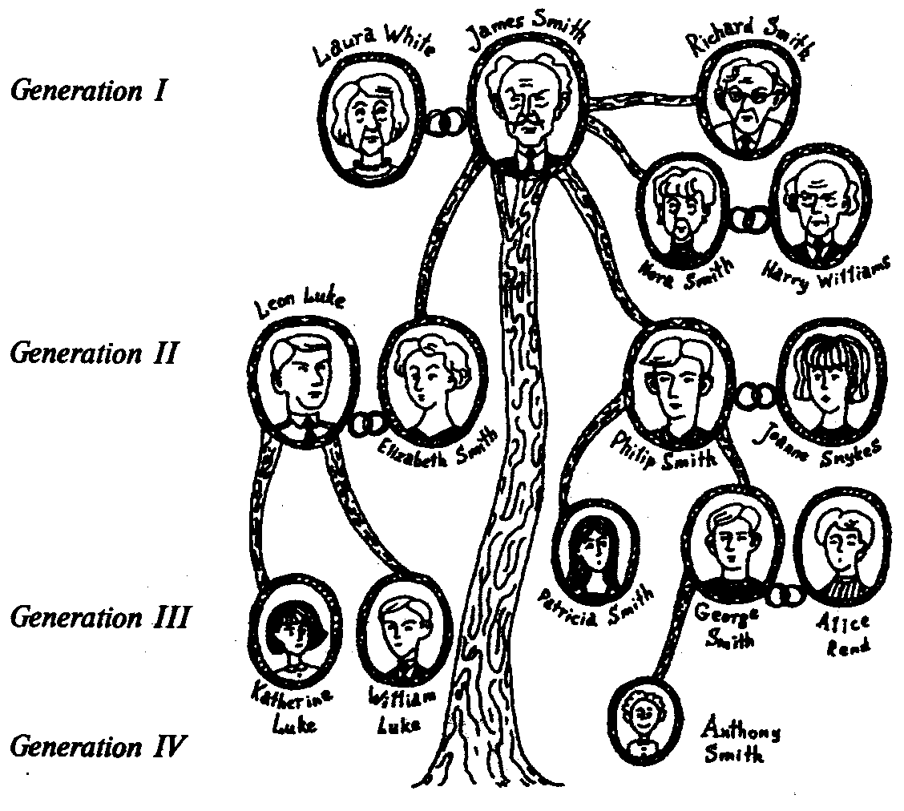

Task 4. Make up a list of positive and negative sides of family life. Compare your lists with those of your groupmates. Comment on the results.

Positive | Negative
Task 5. Try this little brain-teaser. Each of the fourteen people below is married to one of the others. From the information you are given, find out who is married to whom. Note there are three generations here.
Alan is Caroline’s nephew and Larry’s cousin.
Barbara is Larry’s mother and Maggie’s sister-in-law.
Caroline is Edward’s daughter and Maggie’s sister-in-law.
David is Gordon’s brother-in-law and Alan’s uncle.
Edward is Ingrid’s grandfather and Maggie’s father-in-law.
Fanny is Caroline’s mother and Alan’s grandmother.
Gordon is Helen’s son-in-law and Nigel’s brother-in-law.
Helen is Barbara’s mother-in-law and Larry’s grandmother.
Ingrid is Gordon’s niece and David’s daughter-in-law.
John is David’s father and Gordon’s father-in-law.
Karren is Gordon’s daughter-in-law and Maggie’s daughter-in-law.
Larry is John’s grandson and David’s son.
Maggie is Larry’s aunt and Fanny’s daughter-in-law.
Nigel is Ingrid’s father and Fanny’s son-in-law.
Task 6. Translate the following announcement.
Я ищу себе жену. Какой она должна быть?
Я не требую от неё интересной внешности. Пусть у неё будет только стройная фигура и красивое лицо.
Она должна быть весёлой, когда я шучу. И шутить, когда я прихожу домой навеселе.
Меня не интересует её жилплощадь. Главное — чтобы она была большая.
Не интересует меня и её зарплата. Лишь бы она была больше моей.
А вот расходы на свадьбу — поровну; половину внесёт она, а другую — её родители.
Я уверен: когда мы поженимся, у нас появятся общие интересы. Если, например, она не захочет идти со мной на футбол, то мы останемся дома и будем смотреть по телевизору хоккей.
Я буду заботиться о её здоровье. Чтобы к ней не попадало спиртное, табачное, мучное и сладкое, я буду всё это уничтожать сам.
Она будет у меня одеваться как богиня: просто и недорого.
Я возьму на себя часть её работы, если, конечно, она возьмёт на себя всю мою.
Мне не важно, как она будет готовить. Лишь бы это было вкусно. И необязательно, чтобы это была только русская кухня. Здесь у неё полная свобода: сегодня кухня грузинская, а завтра — венгерская утром и китайская вечером.
Я ищу себе жену.
Я готов отдать ей полжизни, если она отдаст мне свою целиком.
Если её не будут удовлетворять мои требования, пусть ищет себе нового мужа.
Вот уже много лет я ищу себе жену.
(из "Литературной Газеты")

Task 7. Read the text and do the exercises.
A Marriage of Convenience
(Story by W. S. Maugham. Abridged.)

I left Bangkok on a shabby little ship. I had gone on board early in the morning and soon discovered that I was thrown amid the oddest collection of persons I had ever encountered. There were two French traders and a Belgian colonel, an Italian tenor, the American proprietor of a circus with his wife, and a retired French official with his.
The French official had been accompanied on board by the French minister at Bangkok, one or two secretaries and a prince of a royal family. He was evidently a person of consequence. I had heard the captain address him as Monsieur le Gouverneur.
Monsieur le Gouverneur was a little man, well below the average height, and smally made, with a very ugly little face; he had a bushy grey head, bushy grey eyebrows, and a bushy grey moustache. He did look a little like a poodle and he had the poodle's soft, intelligent and shining eyes.
The Governor's wife was a large woman, tall and of a robust build. She towered over her diminutive husband like a skyscraper over a shack. He talked incessantly, with vivacity and wit, and when he said anything amusing her heavy features relaxed into a large fond smile.
In such a small ship having once made the acquaintance of my fellow passengers, it would have been impossible, even had I wished it, not to pass with them every moment of the day that I was not in my cabin.
Talking of one thing and another we watched the day decline, we dined, and then we sat out again on deck under the stars. Soon, influenced perhaps by the night, the Italian tenor, accompanying himself on his guitar began to sing. He had the real Italian voice, and he sang the Neapolitan songs.
I saw that the little French Governor had been holding the hand of his large wife and the sight was absurd and touching.
'Do you know that this is the anniversary of the day on which I first saw my wife?' he said, suddenly breaking the silence. 'It is also the anniversary of the day on which she promised to be my wife. And, which will surprise you, they were one and the same.'
'You see, ours was a marriage of convenience pure and simple.'
'C'est vrai,' said the lady. 'But sometimes love comes after marriage and not before, and then it is better. It lasts longer.'
'You see, I had been in the navy, and when I retired I was forty-nine. I was strong and active and I was very anxious to find an occupation. And presently I was sent for by the minister to the Colonies and offered the post of Governor in a certain colony. The minister told me that I must be ready to start in a month. I told him that would be easy for an old bachelor.'
'You are a bachelor?'
'Certainly,' I answered.
'In that case I am afraid I must withdraw my offer. For this position it is essential that you should be married.'
'It is too long a story to tell you, but the gist of it was that owing to the scandal my predecessor had caused, it had been decided that the next Governor must be a model of respectability. I expostulated. I argued. Nothing would serve. The minister was adamant.'
'Well, think it over/ said the minister. 'If you can find a wife in a month you can go, but no wife no job.'
I walked away from the ministry with death in my heart. Suddenly I made up my mind. I walked to the offices of the Figaro, composed an advertisement, and handed it in for insertion. You will never believe it, but I had four thousand three hundred and seventy-two replies. It was an avalanche. It was hopeless, I had less than a month now and I could not see over four thousand aspirants to my hand in that time. I gave it up as a bad job. I went out of my room hideous with all those photographs and littered papers and to drive care away went on to the boulevard and sat down at the Cafe de la Paix. After a time I saw a friend passing. My friend stopped and coming up to me sat down.
'What is making you look so glum?' he asked me.
I was glad to have someone in whom I could confide my troubles and told him the whole story. He laughed. Controlling his mirth as best he could, he said to me: 'But, my dear fellow, do you really want to marry?' At this I entirely lost my temper.
'You are completely idiotic,' I said. 'If I did not want to marry, do you imagine that I should have spent three days reading love letters from women I have never set eyes on?'
'Calm yourself and listen to me,' he replied. 'I have a cousin who lives in Geneva. She is Swiss. Her morals are without reproach, she is of a suitable age, a spinster, for she has spent the last fifteen years nursing an invalid mother who has lately died, she is well educated and she is not ugly.'
'There is one thing you forget. What inducement would there be for her to give up her accustomed life to accompany in exile a man of forty-nine who is by no means a beauty?'
When I made this remark to my friend he replied: 'One can never tell with women. There is something about marriage that wonderfully attracts them. There would be no harm in asking her. '
'But I do not know your cousin and I don't see how I am to make her acquaintance.'
'I will tell you what to do,' said my friend. 'Go to Geneva and take her a box of chocolates from me. You can have a little talk and then if you do not like the look of her you take your leave and no harm is done.'
That night I took the train to Geneva. No sooner had I arrived than I sent her a letter to say that I was the bearer of a gift from her cousin. Within an hour I received her reply to the effect that she would be pleased to receive me at four o'clock in the afternoon. As the clock struck four I presented myself at the door other house. She was waiting for me. Imagine my surprise to see a young woman with the dignity of Juno, the features of Venus, and in her expression the intelligence of Minerva. I was so taken aback that I nearly dropped the box of chocolates. We talked for a quarter of an hour. And then I said to her.
'Mademoiselle, I must tell you that I did not come here merely to give you a box of chocolates. I came to ask you to do me the honour of marrying me.'
She gave a start.
'But, monsieur, you are mad,' she said.
Then I repeated my offer.
'I will not deny that your offer has come as a surprise. I had not thought of marrying, I have passed the age. I must consult my friends and my family.'
'What have they got to do with it? You are of full age. The matter is pressing. I cannot wait. '
'You are not asking me to say yes or no this very minute? That is outrageous.'
'That is exactly what I am asking.'
'You are quite evidently a lunatic.'
'Well, which is it to be? ' I said. 'Yes or no?'
She shrugged her shoulders. She waited a minute and I was on tenterhooks.
'Yes.'
And there she is. We were married in a fortnight and I became Governor of a colony. 'I married a jewel, my dear sirs, one in a thousand.'
He turned to the Belgian colonel.
'Are you a bachelor? If so I strongly recommend you to go to Geneva. It is a nest of the most adorable young women.'
It was she who summed up the story.
'The fact is that in a marriage of convenience you expect less and so you are less likely to be disappointed. Passion is all very well, but it is not a proper foundation for marriage. For two people to be happy in marriage they must be able to respect one another, and their interests must be alike; then if they are decent people and are willing to give and take, to live and let live, there is no reason why their union should not be as happy as ours.' She paused. 'But, of course, my husband is a very remarkable man.'

Exercise 1

Find in the text the English equivalents for the following Russian words and phrases.

A.
Брак по расчёту; годовщина; составить объявление; претендент(ка) на чью-либо руку; поделиться с кем-либо своими проблемами; любовное послание; подходящего возраста; незамужняя женщина; преподнести коробку конфет от чьего-либо имени; оказать честь выйти замуж; выйти из определённого возраста; быть совершеннолетним; один на тысячу; страсть — это прекрасно, но...; хорошая основа для брака; быть счастливым в браке; уважать друг друга; союз.
В.
Сопровождать; важная персона; обращаться к кому-либо; намного ниже среднего роста; возвышаться над кем-либо; познакомиться; говорить о том, о сём; на палубе; нарушить тишину; служить во флоте; ничего не помогало; решить; развеяться; изо всех сил; выйти из себя; в глаза не видеть кого-либо; никоим образом; быть удивлённым; уронить; вздрогнуть; дело безотлагательное; пожать плечами; быть как на иголках; очень рекомендовать; закончить рассказ.

Exercise 2

Put in the missing prepositions or postpositions if necessary.

1. I felt deep sorrow and wanted to confide my troubles ... somebody.
2. The children were so much taken ... that they could not speak for a while; then they decided to think it... .
3. You don't need to consult ... anybody, you have already passed ... the age when people depend on others.
4. The best way to drive care ... is to sit... a cafe.
5. One never knows how to address ... young ladies — Miss or Mrs.
6. A lot of people have never set eyes ... skyscrapers.
7. The lady at the table shrugged ... her shoulders and sent... the waiter.
8. Not everyone has enough tolerance to nurse ... elderly people but those who have, never give it... .
9. I encountered ... my old friend in the street, we went to a cafe and talked ... so many things.
10. The most difficult thing for a young author is to hand ... his manuscript to the editor.
11. Younger people are easily influenced ... all sorts of things they see or hear.
12. When the lady was pleased her lips relaxed ... a smile.
13. Quite often the students are asked to sum ... the story.
14. The tenor sang and his assistant accompanied him ... the guitar.

Exercise 3

Match the English idioms in the left column with their Russian equivalents in the right column. Use them in a proper context.

1. a maiden name А. маменькин сынок
2. extremes meet В. быть под каблуком
3. a mother's boy С. с глаз долой, из сердца вон
4. to be out of hand D. строить глазки
5. to be under smb.'s thumb Е. блудный сын
6. out of sight, out of mind F. плоть и кровь
7. to make eyes at smb. G. жить как кошка с собакой
8. the prodigal son Н. отбиться от рук
9. one's own flesh and blood I. девичья фамилия
10. to lead a cat and a dog life J. противоположности сходятся

Exercise 4

Translate the sentences into English using the vocabulary of the text.

1. Кто сможет в сорок лет отказаться от привычной жизни и уехать куда-нибудь далеко, чтобы начать всё сначала?
2. Я думаю, не будет никакого вреда, если мы подробно обо всём поговорим.
3. Я прошу ответить сию секунду.
4. Хотя мне хотелось чем-нибудь заняться и мне предложили хорошую работу, я всё же не был готов начать через день.
5. Говорят, Наполеон был намного ниже среднего роста.
6. Решение пришло неожиданно. Я ушел и отправился побродить, чтобы развеяться.
7. Союз двух людей не сбудет счастливым, если они не уважают друг друга.
8. В этой семье каждый год празднуют годовщину свадьбы.
9. Смотреть на супругов, проживших вместе пятьдесят лет — это трогательное зрелище.
10. В этом доме всегда с радостью принимают гостей.
11. Я очень рекомендую Вам отправиться в путешествие на корабле.
12. Спустя какое-то время ко мне подошёл старый приятель.
13. Подавая брачные объявления в газету, люди чаще всего ищут партнёров подходящего возраста.
14. Кто их разберёт, женщин? Они всё делают по-своему.
15. Изо всех сил стараясь сдержать смех, дама в ответ просто пожала плечами.

Task 8. Read the article and render it according to the plan (see App.1)
Family Matters
James Mitford: My wife and I only had the one child. It might have been nice to have a son, but we didn’t plan a family, we just had Amy.
I see her as my best friend. I think she’d always come to me first if she had a problem. We have the same sense of humour, and share interests. I don’t mind animals, but she’s completely obsessed with them, and she has always had dogs, cats, horses, and goldfish in her life.
We were closest when she was about four, which I think is a lovely age for a child. They know the parents best, and don’t have the outside contacts. She must have grown up suddenly when she went to school, because I remember her growing away from her family slightly. Any father who has a teenager daughter comes across an extraordinary collection of people, and there seemed to be an endless stream of strange young men coming through our house. By the time I’d learned their names they’d gone away and I had to start learning a new lot. I remember I told her offence in front of her friends and she didn’t talk to me for days afterwards.
I wanted more than anything else for her to be happy in what she was doing, and I was prepared to pull strings to help her on her way. She went to a good school, but that didn’t work out. She must have upset somebody. When she left she decided she wanted to become an actress so I got her into drama school. It wasn’t to her liking so she joined a theatre group and began doing bits and pieces of films. She was doing well, but then gave it up. She probably found it boring. Then she took up social work, and finally went to work for a designer and he became her husband. And that’s really the story of her life. She must be happy with him—they’re always together.
We have the same tastes in books and music, but it takes me a while to get used to new pop songs. I used to take her to the opera, which is my big passion, but I don’t think she likes it very much, she doesn’t come with me any more.
I don’t think she’s a big television watcher. She knows when I’m on, and she might watch, but I don’t know. It’s not the kind of thing she tells me.
We’re very grateful for Amy. She’s a good daughter as daughters go. We’re looking forward to being grandparents.
I’m sure she’ll have a son.
Amy Mitford: I don’t really know my father. He isn’t easy .to get on with. He’s quite self-centered, and a little bit vain, I think, and in some ways quite unapproachable. The public must think he’s very easy-going, but at home he keeps himself to himself.
He can’t have been at home much when I was a child, because I don’t remember much about him. He’s always been slightly out of touch with family life. His work always came first, and he was always off somewhere acting or rehearsing. He loves being asked for his autograph, he loves to be recognized. He has won several awards, and he’s very proud of that. He was given the Member of the British Empire, and we had to go to Buckingham Palace to get the medal. It was incredibly boring — there were hundreds of other people getting the same thing, and you had to sit there for hours. He shows off his awards to whoever comes to the house.
I went to public school, and because of my total lack of interest and non-attendance I was asked to leave. I didn’t want to go there in the first place. I was taken away from all my friends. He must have been very pleased to get me into the school, but in the end it was a complete waste of money. I let him down quite badly, I suppose. I tried several jobs but I couldn’t settle down in them. They just weren’t challenging enough. Then I realized that what I really wanted to do was live in the country and look after animals, so that’s what I now do.
As a family, we’re not that close, either emotionally or geographically. We don’t see much of each other these days. My father and I are totally different, like chalk and cheese. My interests have always been the country, but he’s into books, music and above all, opera, which I hate. If they do come to see us, they’re in completely the wrong clothes for the country — mink coats, nice little leather shoes, not exactly ideal for long walks across the fields.
He was totally opposed to me getting married. He was hoping we would breakup. Gerald’s too humble, I suppose. He must have wanted me to marry someone famous, but I didn’t, and that’s all there is to it. We don’t want children, but my father keeps on and on talking about wanting grandchildren. You can’t make someone have children just because you want grandchildren.
I never watch him on television. I’m not that interested, and anyway he usually forgets to tell me when he’s on.
Unit 3

MEALS AND COOKING

Task 1. Look through the following idioms and quotations. Try to guess their meaning and find Russian equivalents. Do you agree or disagree with them?
- 'Tell me what you eat and I will tell you who you are.'
Anthelme Brillat-Savarin
- 'Man is the only animal that can remain on friendly terms with the victims he intends to eat until he eats them.'
Samuel Butler
- 'The whole of nature, as has been said, is a conjugation of the verb to eat in the active and passive.'
William Ralph Inge

Task 2. Read the text paying attention to focus vocabulary.
Meals and cooking

Living in Russia one cannot but stick to a Russian diet. Keeping this diet for an Englishman is fatal. The Russians have meals four times a day and their cuisine is quite intricate.
Every person starts his or her day with breakfast. Poor Englishmen are sentenced to either a continental or an English breakfast. From the Russian point of view, when one has it continental it actually means that one has no breakfast at all, because it means drinking a cup of coffee and eating a bun. A month of continental breakfasts for some Russians would mean starving. The English breakfast is a bit better, as it consists of one or two fried eggs, grilled sausages, bacon, tomatoes and mushrooms. The English have tea with milk and toast with butter and marmalade. As a choice one may have corn flakes with milk and sugar or porridge.
In Russia people may have anything for breakfast. Some good-humored individuals even prefer soup, but, of course, sandwiches and coffee are very popular. One can easily understand that in Great Britain by one o'clock people are very much ready for lunch. Lunch is the biggest meal of the day. That would be music for a Russian's ears until he or she learns what lunch really consists of. It may be a meat or fish course with soft drinks followed by a sweet course.
The heart of a Russian person fills with joy when the hands of the clock approach three o'clock. His or her dinner includes three courses. A Russian will have a starter (salad, herring, cheese, etc.), soup, steaks, chops, or fish fillets with garnish, a lot of bread, of course, and something to drink. The more the better. At four or five the Russians may have a bite: waffles, cakes with juice, tea, cocoa, or something of the kind.
In Great Britain they have dinner at five or six. Soup may be served then, but one should not be misled by the word "soup". British soup is just thin paste and a portion is three times smaller than in Russia. A lot of British prefer to eat out. "Fish and Chips" shops are very popular with their take-away food. The more sophisticated public goes to Chinese, Italian, seafood or other restaurants and experiments with shrimp, inedible vegetables and hot drinks.
Supper in Russia means one more big meal at seven. The table groans with food again. In England it is just a small snack — a glass of milk with biscuits at ten.
Most Russians have never counted calories and they are deeply convinced that their food is healthy. Some housewives may admit that it takes some time to prepare all the stuff, including pickles, home-made preserves and traditional Russian pies and pancakes. But they don't seem to mind too much and boil, fry, roast, grill, broil, bake and make. Paraphrasing a famous proverb one can say:
'What is a Russian man's meat is a British man's poison'.

Task 3. Find out what the following English idioms mean

- to bite off more than one can chew | A. to have a lot of tasks
- to take something with a pinch of salt | B. extremely rich in producing food
- to have a lot on one's plate | C. to be sold out very quickly
- to know which side one's bread is buttered on | D. to make an unpleasant thing seem less
- flowing with milk and honey | E. not to believe entirely
- to sell like hot cakes | F. to be an unwanted member of a trio
- a storm in a tea-cup | G. to know where one is in a position of advantage
- as sure as eggs is eggs | H. for certain
- to play gooseberry | I. to attempt to do more than one can
- to sugar the pill | J. disturbance over a trifling matter

Task 4. Look through the following statements and choose the most appropriate answers.

1. Lemons taste ....
a. salty
b. sour
c. bitter
d. crunchy
e. bland

2. Potato chips are not ….
a. crisp
b. salty
c. crunchy
d. juicy
e. junk food

3. Smooth foods don’t include….
a. crackers
b. ice cream
c. pudding
d. whipped cream
e. avocado

4. In a restaurant, we normally eat an appetizer ….
a. after the entree
b. just before dessert
c. first
d. last
e. only if we are not very hungry

5. If something is filling it is ….
a. the stuff inside a pie
b. something that you eat, but you are still hungry
c. delicious
d. smth. that you eat and you feel full after eating it
e. both a and d
6. Finger food ….
a. makes your fingernails grow longer
b. is only eaten in countries where they don’t have silverware
c. is slang for a bad gesture
d. is food you can politely eat with your hands
e. is the name of a really tasty candy bar

7. Light food is the opposite of ….
a. heavy food
b. rich food
c. bland food
d. junk food
e. health food

8. If something is tasty, you ….
a. don’t really enjoy eating it
b. think it tastes good
c. hate eating it
d. only eat it for breakfast
e. think it is unappetizing

9. Spicy food includes ….
a. milk
b. lemons
c. chili peppers
d. bananas
e. hamburgers

10. If milk is sour it is ….
a. delicious
b. too old
c. too fresh
d. from a goat
e. from a coconut

11. A beverage is ….
a. Beverley’s birthday
b. something red
c. an alcoholic drink
d. any drink
e. normally crunchy

12. All of these are bitter except …
a. black coffee
b. strong tea without sugar or milk
c. unsweetened baking chocolate
d. pizza
e. a and c

13. Appetizing means ….
a. you would like to eat it
b. the first course at a restaurant
c. yucky
d. tangy
e. finger food

14. Sweet foods don’t include ….
a. cake
b. pickles
c. ice cream
d. candy
e. strawberries

15. Rich food is always ….
a. salty
b. crunchy
c. dessert
d. fattening
e. expensive

Task 5. Read the text and do the exercises.

Luncheon
(by Somerset Maugham)

I caught sight of her at the play and in answer to her beckoning I went over during the interval and sat down beside her. It was long since I had last seen her and if someone had not mentioned her name I do not think I would have recognized her. She addressed me brightly.
"Well, it's many years since we first met. How time flies! We are not getting any younger. Do you remember the first time I saw you? You asked me to, luncheon."
Did I remember? It was twenty years ago and I was living in Paris. I had a tiny apartment in the Latin Quarter' and I was earning barely enough money to keep body and soul together.
She had read a book of mine and had written to me about it. I answered, thanking her, and presently I received from her another letter saying that she was passing through Paris and would like to have a chat with me; but her time was limited and the only free moment she had was on the following Thursday. She asked me if I would give her a little luncheon at Foyot's. Foyot's is a restaurant at which the French senators eat and it was so far beyond my means that I had never even thought of going there. But I was flattered and I was too young to say no to a woman. I had eighty francs to live on till the end of the month and a modest luncheon should not cost more than fifteen. If I cut out coffee for the next two weeks I could manage well enough.
I answered that I would meet her at Foyot's on Thursday at half past twelve.
She was not so young as I expected and in appearance imposing rather than attractive. She was in fact a woman of forty, and she gave me the impression of having more teeth, white and large and even, than were necessary for any practical purpose. She was talkative, but since she seemed inclined to talk about me I was prepared to be an attentive listener. I was startled when the menu was brought, for the prices were a great deal higher than I had expected. But she reassured me.
"I never eat anything for luncheon," she said.
"Oh, don't say that!" I answered generously.
"I never eat more than one thing. I think people eat too much nowadays. A little fish, perhaps. I wonder if they have any salmon."
Well, it was early in the year for salmon and it was not on the menu, but I asked the waiter if there was any. Yes, they had a beautiful salmon, it was the first they had had. I ordered it for my guest. The waiter asked her if she would have something while it was being cooked.
"No," she answered, "I never eat more than one thing. Unless you had a little caviar.' I never mind caviar."
My heart sank a little. I knew I could not afford caviar, but I could not tell her that. I told the waiter by all means to bring caviar. For myself I chose the cheapest dish on the menu and that was a mutton chop.
"I think you're unwise to eat meat," she said. "I don't know how you can expect to work after eating heavy things like chops. I never overload my stomach."
Then came the question of drink.
"I never drink anything for luncheon," she said.
"Neither do I," I answered promptly.
"Except white wine," she went on as though I had not spoken. "These French white wines are so light. They are wonderful for the digestion."
"What would you like?" I asked her.
"My doctor won't let me drink anything but champagne." I think I turned a little pale. I ordered half a bottle. I mentioned casually that my doctor had absolutely forbidden me to drink champagne.
"What are you going to drink, then?"
"Water."
She ate the caviar and she ate the salmon. She talked gaily of art and literature and music. But I wondered what the bill would come to. When my mutton chop arrived she said:
"I see that you're in the habit of eating a heavy luncheon. I'm sure it's a mistake. Why don't you follow my example and just eat one thing? I'm sure you'd feel much better then."
"I am only going to eat one thing," I said, as the waiter came again with the menu.
She waved him aside with a light gesture.
"No, no, I never eat anything for luncheon. Just a bite, I never want more than that. I can't eat anything more unless they had some of those giant asparagus. I should be sorry to leave Paris without having some of them."
My heart sank. I had seen them in the shops and I knew that they were horribly expensive. My mouth had often watered at the sight of them. "Madame wants to know if you have any of those giant asparagus," I asked the waiter. I hoped he would say no. A happy smile spread over his broad face, and he assured me that they had some so large, so splendid, so tender, that it was a marvel.
"I'm not in the least hungry," my guest sighed, "but if you insist I don't mind having some asparagus."
I ordered them.
"Aren't you going to have any?"
"No, I never eat asparagus."
"I know there are people who don't like them."
We waited for the asparagus to be cooked. Panic seized me. It was not a question now how much money I should have left for the rest of the month, but whether I had enough to pay the bill. It would be terrible to find myself ten francs short and be obliged to borrow from my guest. I could not bring myself to do that. I knew exactly how much money I had and if the bill came to more I made up my mind that I would put my hand in my pocket and with a dramatic cry start up and say my money had been stolen. If she had not money enough to pay the bill then the only thing to do would be to leave my watch and say I would come back and pay later.
The asparagus appeared. They were enormous and appetizing. The smell of the melted butter tickled my nostrils. I watched the woman send them down her throat and in my polite way I talked on the condition of the drama in the Balkans. At last she finished.
" Coffee?" I said.
"Yes, just an ice-cream and coffee," she answered.
It was all the same to me now, so I ordered coffee for myself and an ice-cream and coffee for her.
"You know, there's one thing I thoroughly believe in," she said, as she ate the ice-cream. "One should always get up from a meal feeling one could eat a little more."
"Are you still hungry?" I asked faintly.
"Oh, no, I'm not hungry; you see, I don't eat luncheon. I have a cup of coffee in the morning and then dinner, but I never eat more than one thing for luncheon. I was speaking for you."
"Oh, I see!"
Then a terrible thing happened. While we were waiting for the coffee, the head waiter, with a smile on his false face, came up to us bearing a large basket full of huge peaches. Peaches were not in season then. Lord knew what they cost. I knew too — a little later, for my guest, going on with her conversation, absent-mindedly took one. "You see, you've filled your stomach with a lot of meat and you can't eat any more. But I've just had a snack and I shall enjoy a peach."
The bill came and when I paid it I found that I had only enough for a quite inadequate tip. Her eyes rested for a moment on the three francs I left for the waiter and I knew that she thought me mean. But when I walked out of the restaurant I had the whole month before me and not a penny in my pocket.
"Follow my example," she said as we shook hands, "and never eat more than one thing for luncheon."
"I'll do better than that," I answered. "I'll eat nothing for dinner tonight."
"Humorist!" she cried gaily, jumping into a cab. "You're quite a humorist!"
But I have had my revenge at last. Today she weighs twenty-one stone.'

Exercise 1
I. Pick out from the text words and expressions denoting:
a) food, b) drinks, c) adjectives used to describe dishes.

II. Pick out from the text:
a) all phrases used to characterize the process of eating;
b) all phrases used to describe a restaurant setting.

Exercise 2
Match the words on the left with their definitions on the right.
1. salmon a) а list of dishes to be ordered in a restaurant
2. caviar b) as much food or drink as fills the mouth
3. menu c) a meal eaten in the middle of the day
4. champagne d) a plant whose young shoots are cooked and eaten as vegetable
5. chop e) the ability to judge food or wine
6. bill f) white sparkling French wine
7. asparagus g) gift of money to a porter, waiter for services
8. waiter h) a person’s ability to change food into a form that the body can use
9. palate i) the salted eggs of various fish
10. tip j) a man who serves food in a restaurant
11. dinner k) a list of things bought and their price
12. mouthful l) the main meal of the day
13. digestion m) a large fish with silvery skin and yellowish-pink flesh
14. luncheon n) a small piece of meat, eaten as a food

Exercise 3
A: Пригласить на ланч; меню; есть слишком много; заказать что-либо для кого-либо; позволить себе икру; самое дешевое блюдо в меню; отбивная из баранины; есть сытную пищу; перегружать желудок; французские белые вина; очень полезный для пищеварения; ничего, кроме шампанского; каким будет счёт; обильный ланч; лёгкая закуска; спаржа; слюнки текут; чудо; ничуть не голоден; портить вкус к еде; оплатить счёт; сочный; аппетитный; щекотать ноздри; большие аппетитные куски; закончить еду; вставать из-за стола; метрдотель; не сезон для чего-либо; лишь перекусить; недостаточные чаевые.
В: Увидеть кого-либо; еле сводить концы с концами; быть проездом в Париже; поговорить с кем-либо; быть не по средствам; сердце ёкнуло; слегка побледнеть; отчитать кого-либо за что-либо; иметь привычку; рассуждать о чём-либо; быть совершенно уверенным; остановиться на минуту (о взгляде); следовать примеру кого-либо.

Exercise 4
Find in the text words or phrases similar in meaning to the following. Read aloud the sentences containing them.
To make two ends meet; to listen attentively; to be surprised a lot; nourishing dishes; to grow a little pale; not to allow; to be used to eat; to cost awfully much; to beam happily; to swallow big delicious bits; to be out of seasons; to stop for a moment.

Exercise 5
Complete the following sentences choosing the appropriate word or phrase from the list. Change the form of the words or add some words if necessary.
To eat far too much; what the bill would come to; one’s mouth watered; a quite inadequate tip; the cheapest dish on the menu; to pay the bill; to eat nothing for dinner; to tickle one’s nostrils; to have a snack; in large voluptuous mouthfuls; succulent and appetizing; not to be in the least hungry; a heavy luncheon; to order coffee smb.
1. The smell of the delicious spicy meat, being cooked in the kitchen, ………., and our appetite grew with every minute.
2. As Mrs Coke had indigestion on that day and didn’t feel well, she decided ………….
3. Pizza was ……………, and as we had already run out of money, we ordered that.
4. At the sight of all the delicacies Sam’s ………. and he could hardly wait for the beginning of the dinner.
5. Betsy is putting on weight so quickly. I think she ………………………
6. John was so hungry that he didn’t mind having ……………… at all; in fact, he thought he could eat a pile of food.
7. Mary offered some food to Robert, but he refused, saying that he had just had his lunch and ……………………………………
8. A pound is …………………. for a good meal in a good place; the tip should make up ten per cent of the meal cost.
9. The food Thomas ordered in a restaurant was terribly expensive, but it was his usual way: he never thought ………………….
10. The waiter came up to our table, and Mr Dartmond ……………….…… both of us.
11. We were short of time and that’s why we decided not to go to a restaurant, but …………. in a street cafe.
12. The hostess brought in a huge dish with roast turkey. It was ……, a real Christmas treat.
13. She took out her purse ……….., but Mr Donald stopped her, saying that she was his guest and he wouldn’t let her pay for the meal.
14. The roast pork looked succulent and tender, and the hungry men started their meal, swallowing the meat ………….

Exercise 6
Insert the missing prepositions if necessary.
1. He knew that he would be passing ... Berlin and called his friend who lived there to inform him about it.
2. Don’t believe ... all sorts of nonsense they write in gutter press.
3. We asked our new friends from France ... lunch at Radison’s.
4. The family ate some roast meat with vegetables ... lunch.
5. The guests were talking ... music and literature, sports and entertainments.
6. I remember I saw lobster ... the shop in Reed Street.
7. The mother taught her daughters to get up ... a meal feeling a little hungry.
8. Her eyes rested ... a minute ... a rich cake, but she refused it, though with an effort.
9. Terry had only £20 and whole week ... him to live in London.
10. It’s easy to ruin one’s palate ... eating lots of spicy food.
11. A smile spread ... the face of the waiter.
12. Tourists are advised to eat ... the Blue Elephant, famous for its Thai food.
13. Strawberries were ... season, and we ordered them with whipped cream.
14. Peter had already filled his stomach ... a lot of food and could eat nothing more.

Task 6. Read the article and render it according to the plan (see App.1)

FOOD FOR THOUGHT

There has been a lot of hype over intermittent fasting in the past few years, with some science backing, but what exactly is it all about?
By Lauren Bell
22nd August 2018, 11:01 am

The intermittent fasting diet does what it says on the tin, but it can follow two patterns. The first is eating just 500 calories two days per week, and eating normally (what you want) the other five days. The second option is going 14, 16 or 18 hours a day without food, leaving you with a six to ten hour window to eat in. The time in which your body starts to break down fat is after all digestion is fully completed and the nutrients have been taken from food. This period after is called the post-absorptive state where excess fat will be stored in the liver for fuel stores, where it can be acessed to keep the body's functions ticking over when no energy from food is in the digestive system to use. This is what happens when you sleep and when you are in a planned fasting period and insulin is low. Your body will need to take from fat stores even more whilst awake and fasting, as you'll need more energy to move around, which is when the weight loss occurs.
In a study by The University of Surrey, researchers assigned 27 overweight people to either a 5:2 diet (fasting on 600 kcals two days a week), or a calorie restrictive diet (1400 kcals per day for women and 1900 for men) and the aim was to lose 5% of their weight. The results showed it took the 5:2 dieters 59 days to achieve their 5% weight loss target, while it took the calorie cutters 73 days. It also showed the 5:2 dieters cleared the fat from their blood post-meals quicker. However, several people dropped out of the study and the focus group was very small.
Other research undertaken on the effects of intermittent fasting at Utah's non-profit Intermountain Healthcare system showed that when compared with traditional calorie-cutting weight loss plans, people on intermittent fasting diets lost more weight.
Studies show fat loss is more effective on an intermittent fasting diet than a calorie restricted one
• The main benefit is eating what you want on the non-fasting days, which might encourage dieters to stick to the plan.
• Some studies on animals have shown health benefits other than fat loss like lowering the risk of heart disease.
• In the earlier mentioned study by The University of Surrey, research showed blood pressure (systolic), was reduced by 9% on participants following the 5:2 diet compared to just 2% for the calorie cutters. A reduction in blood pressure will take pressure off the arteries and potentially reduce the chance of strokes and heart attacks.
• There is some evidence to suggest it may have an anti-ageing effect.
There are many benefits, including eating what you like (within reason) on non-fasting days
Fasting days are hard, especially to begin with, but it should get easier.
It could also impact your social life, if you let it.
The good news is you can plan around it on the 5:2 and choose days when you're staying in, or on the 12-14 hour daily fasts you could start eating later that morning to counteract your later evening meal with friends.
It does take more planning though and allows for less spontaneity.
Although studies seem to be positive, it is not yet clear whether there will be long-term effects, or whether it's likely to encourage eating disorders.
Appendix 1

The Plan For Rendering The Article

 | The Headline/ Title of the Article | The article is headlined...  The article goes under the headline...  The article under the headline... has the subhead...
 | The Place of Origin | The article is printed/ published in...  The article is from а newspaper under the nameplate...
 | The Time of Origin | The publication date of the article is...  The article is dated the first of October 2017  The article is printed on the second of October in 2017
 | The Author | The article is written by…  The author of the article is...  The article is written by а group of authors
 | The Theme/ Topic | The article deals with the topic...  The basic subject matter of the script is...  The article touches upon the topic of...  The headline of the article corresponds to the topic…
 | The Main Idea/ Aim of the Article | The purpose of the article/ author is to give the reader some information on...; to inform with...; to compare/ determine...; to provide the reader with some material/ data on...
 | The Contents of the Article (а short summary in 3 or 4 sentences) | The article can be divided into ‘some’ parts  (The first part deals with..., the second covers the events, the third touches upon the problem of..., the fourth part includes some interviews, dialogues, pictures, reviews, references, quotations, figures...)  The article is written in the form of the monologue, from the first/ third person narration.  In the video report we come across an interview, historical facts, а speech of..., the picture from the place of events.  The author starts by telling the reader... (writes, states, stresses, depicts, says, informs, underlines, confirms, emphasizes, puts an accent on, accepts/ denies the fact, reports, resorts to, hints on, inclines to and so on)  The article describes, goes on to say...  The key sentences/ words of the article... are the following...
 | The Vocabulary of the Article:  -the topical voc.  -the author's voc. | While reading I've come across some topical words and expressions like...  A great number of words belong to the topic …  The author's vocabulary is rather vivid, poor, rich …  The author resorts to colorful general phrases/ clichés/ stable statements/ understatements/ exaggerations/ words with negative/ positive connotation/ fine words/ descriptive adjectives/ comparisons (to create а vivid picture, а humorous effect/ to enforce the influence the reader)  We see the author's mastery in conveying the main idea to the reader with the help of the phrases/ parenthesis/ sayings/ proverbs …
 | Personal Opinion/ Impression of the Article | I found the article interesting/ important/ hard to understand (Why?)  I appreciate the author's word-painting as superb/ ordinary/ exaggerated …
 | Personal View on the Topic/ Idea/ Problem | The message of the writer is clear to understand...  I share the author's view…  I don't quite agree with the fact...

References
- Baigent, M. Natural English Reading & Writing Skills, Upper-Intermediate Resource Book / M. Baigent. – Oxford University Press, 2004. – 64p.
- McGavigan, P., Reeves, J. First Certificate Reading / P. McGavigan, J. Reeves. – Pearson Education Limited, 2001. – 146p.
- Mann, M., Taylore-Knowles S. Skills for First Certificate Reading / M. Mann, S. Taylore-Knowles. – Macmillan Publishers Limited, 2006. – 176p.
- Thomas, B.J. Advanced Vocabulary and Idioms / B.J. Thomas. – Pearson Education Limited, 2008. – 128 p.
- Меркулова, Е.М. Reading, Writing and Conversation / Английский язык. Чтение, письменная и устная практика / Е.М. Меркулова. – Союз, 2007. – 387с.
- The Busy Teacher [Электронный ресурс]. – Режим доступа: www.busyteacher.org. – Дата доступа: 23.09.2018.
- The Journal of Young Investigators [Электронный ресурс]. – Режим доступа: www.jyi.org. – Дата доступа: 23.09.2018.
- The New York Times [Электронный ресурс]. – Режим доступа: www.nytimes.com. – Дата доступа: 23.09.2018.
- The StudFiles [Электронный ресурс]. – Режим доступа: www.studfiles.net. – Дата доступа: 23.09.2018.
- The Sun [Электронный ресурс]. – Режим доступа: www.thesun.co.uk. – Дата доступа: 23.09.2018.

