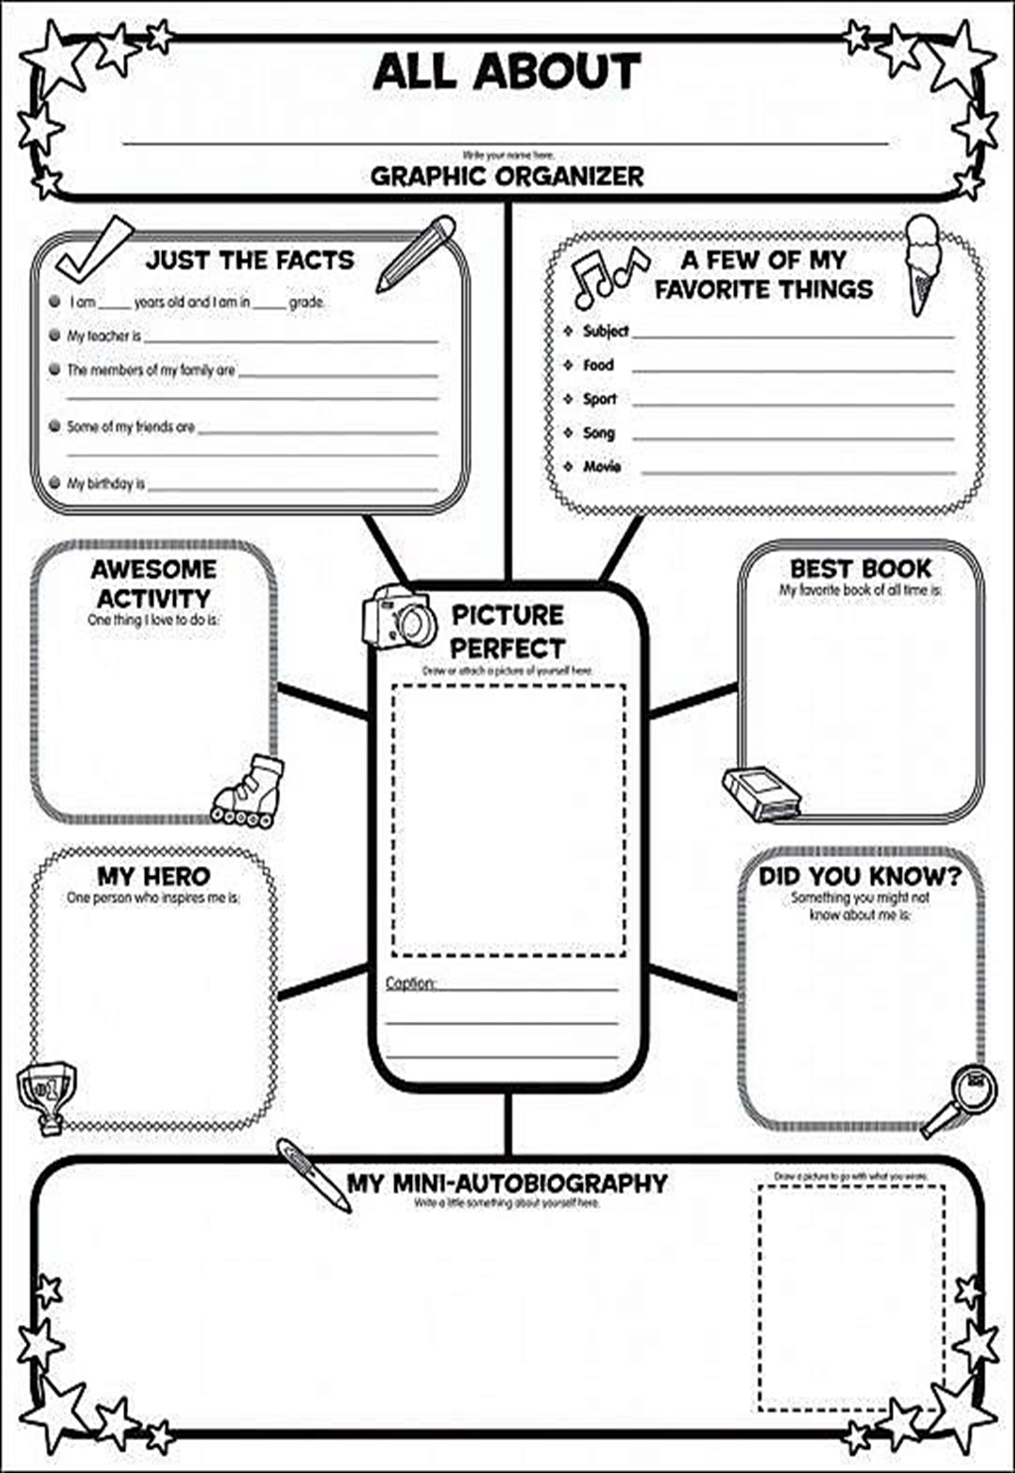**ОБРАЗЦЫ ЗАДАНИЙ ДЛЯ САМОСТОЯТЕЛЬНОЙ РАБОТЫ** *(Example 1: Fill in your portfolio* *and introduce yourself to the class)*

*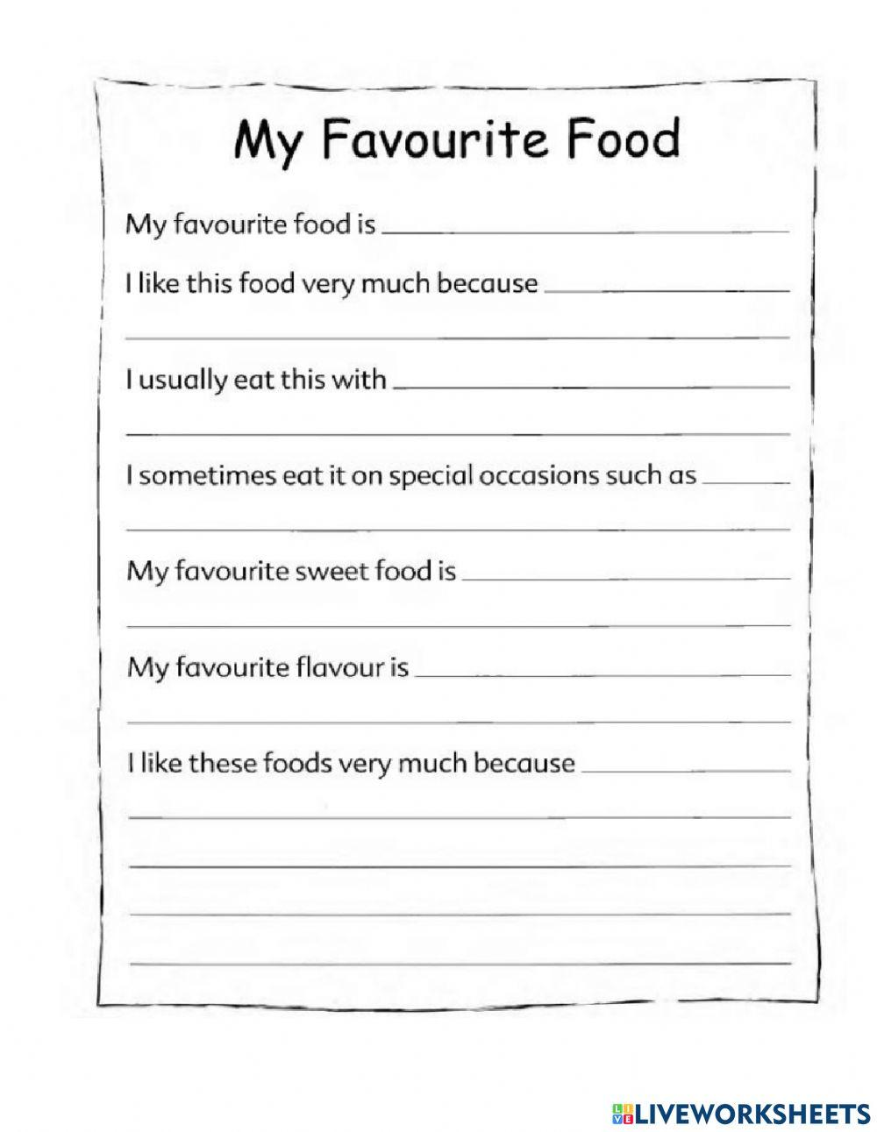(Example 2: Finish the given statements about your food preferences and share the information with the class)*

*(Example 3: Write a short passage and read it to the class)*

Write a short passage starting each line with the given letter. Make sure your sentences correspond to the topic indicated by the first letters of the line if your read them vertically

**M**

**Y**

**S**

**U**

**M**

**M**

**E**

**R**

**W**

**A**

**S**

**B**

**E**

**C**

**A**

**U**

**S**

**E**